Last Updated: January 2021

Explorer Version: USFS.2020.5

# OVERVIEW: LCMS Data Explorer

Introduction

This guide provides an overview for navigating and downloading data produced for the USDA Forest Service’s Landscape Change Monitoring System (LCMS) using the LCMS Data Explorer. The LCMS Data Explorer is the best tool for quickly viewing and downloading available data products.

The LCMS Data Explorer can be found at: <https://apps.fs.usda.gov/lcms-viewer/>

Objectives

* Learn how to navigate the LCMS Data Explorer web application.
* Download data from the LCMS Data Explorer.

Required Software

* A web browser other than Microsoft Internet Explorer (Tested on Chrome, Firefox, and Edge).

Prerequisites

* Basic understanding of how to use a simple GIS, such as Google Maps or Google Earth.

Contacts

* LCMS general inquires: [sm.fs.lcms@usda.gov](mailto:sm.fs.lcms@usda.gov) 801-975-3841

Table of Contents

Part 1: Navigating the LCMS Data Explorer 3

Part 2: Menu Options & Tools 5

Part 3: Download Data & Support Tabs 14

1. Navigating the LCMS Data Explorer

This section introduces the user to general navigation and functionality of the LCMS Data Explorer.

* 1. 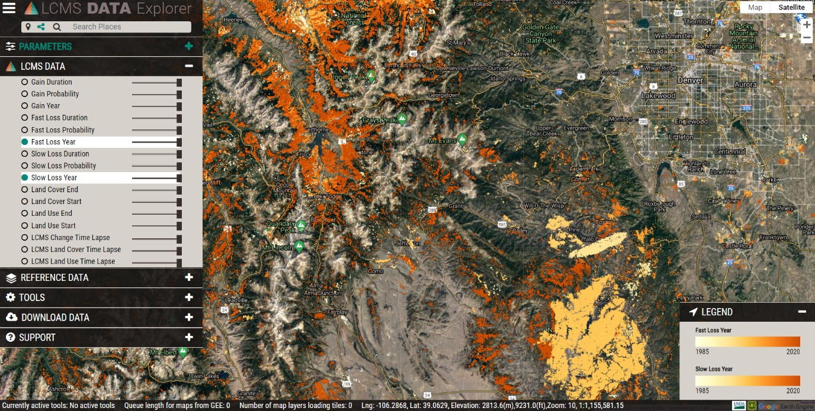Explore the Google Tools

Launch the LCMS Data Explorer by [clicking this link](https://apps.fs.usda.gov/lcms-viewer/) (https://apps.fs.usda.gov/lcms-viewer). The tools along the upper-right side of the browser window are the default tools within all web mapping applications using Google Maps.

* + 1. At the top right you can choose between **map** view and **satellite** view for your base layer.
       1. **Map** view has a checkbox drop-down option to turn terrain view on and off.
       2. **Satellite** view has a checkbox drop-down option to turn labels on and off.
    2. Below the full screen button are zoom tools for viewing the map at different scales.
       1. Zoom In and Out can also be accomplished using the scroll wheel on your mouse.
    3. The orange person icon allows you to drop into street view.

Street view icon

* + - 1. You can click and drag the person onto the map area. Any area that becomes highlighted in blue is available for you to drop the person to see surface level imagery in that area.
      2. To exit street view, click the left-pointing arrow in the upper left corner of the window.
  1. Viewer Information Ribbon & Legends
     1. For additional information on a tool or layer, hover the mouse over the name and additional text will appear (if available).
     2. Navigate to the ribbon of text along the bottom of the data viewer.

The info bar contains various bits of information pertaining to the viewer and the data

* + - * 1. **Currently active tools:** Which tools are turned on.
        2. **Queue length for maps from GEE:** How many data layers still need to load.
        3. **Number of map layers loading tiles**: How many of the enabled layers that are actively loading tiles.
        4. **Lat/Long, Elevation**: Coordinates of the mouse location.
        5. **Zoom**: Map view extent.



* + 1. The legend, located on the bottom right of the viewer, will display information about LCMS and Reference Data products that are turned on.

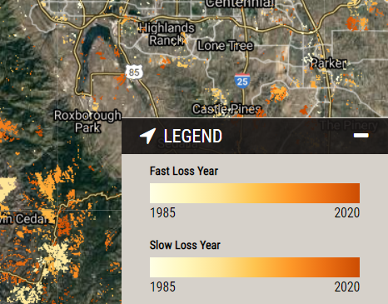

1. Menu Options & Tools

,analysisforing the

* 1. Parameters tab

The menus and associated options are located along the left side of the browser window. To show the options under each heading, maximize the menu tabs by clicking the “+” on the right side of the tab. When you are ready to minimize the tab, simply click the “-“.

* + 1. 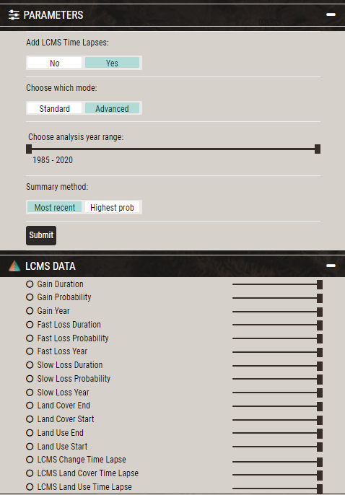**Add LCMS Time Lapses:** Choose “Yes” if you would like to view an interactive time lapse of LCMS change, land cover, and/or land use products. These time lapses are created on-the-fly and can be very slow to load, but provide a very useful method for visualizing LCMS products across time.
    2. **Choose which mode:** 
       1. **Standard** mode will load all core LCMS layers.
       2. **Advanced** mode will load additional LCMS Layers and allow you to choose the summary mode for change layers in the viewer.
          1. **Most recent** year of change (default if using Standard mode), will show the most recent year of slow loss, fast loss, and gain LCMS detected.
          2. **Most probable** year of change will show the year with the highest probability of slow loss, fast loss, and gain LCMS detected.
    3. The analysis year range can be modified from “1985-2020”
    4. Once you are finished changing any parameters, refresh the maps by clicking the **Submit** button.
       1. If the Submit button is disabled, either the selected options are already being processed or other layers are loading and you will need to wait for them to finish.
  1. LCMS Data tab
     1. To explore the LCMS products, click on the **LCMS Data** tab located under the **Parameters** tab.
     2. Hover over each layer name for additional text that describes the layer.
     3. The following products will be shown depending on what parameters you chose:
        1. **Standard mode** (default)
           1. 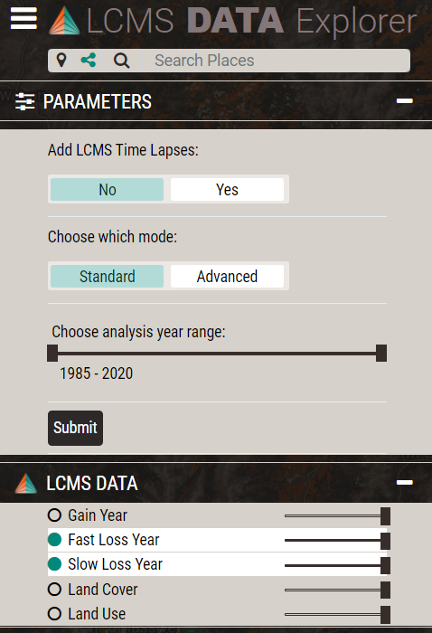Gain Year (Year of most recent vegetation cover gain)
           2. Fast Loss Year (Year of most recent rapid vegetation cover loss from an external event such as fire/harvest, or change from water inundation/desiccation, etc.)
           3. Slow Loss Year (Year of most recent vegetation cover loss from a long-term trend event such as drought, tree mortality from insects or disease, etc.)
           4. Land Cover (most common land cover class)
           5. Land Use (most common land use class)

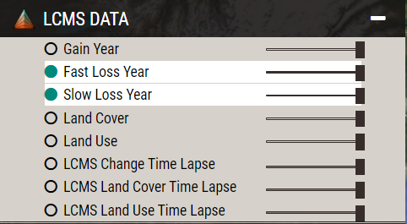

* + - 1. Add LCMS Time Lapses

Additional layers include:

* + - * 1. LCMS Change Time Lapse
        2. LCMS Land Cover Time Lapse
        3. LCMS Land Use Time Lapse
      1. **Advanced mode**

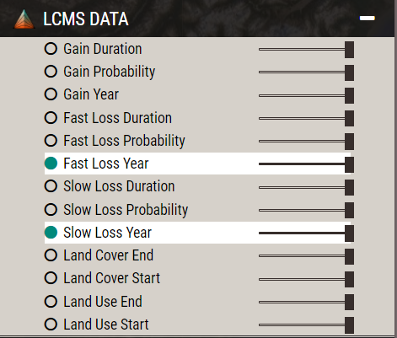Additional layers include:

* + - * 1. Gain Duration
        2. Gain Probability
        3. Fast Loss Duration
        4. Fast Loss Probability
        5. Slow Loss Duration
        6. Slow Loss Probability
        7. Land Cover End (most common land cover class for last 5 years)
        8. Land Cover Start (most common land cover class for first 5 years)
        9. Land Use End (most common land use class for last 5 years)
        10. Land Use Start (most common land use class for first 5 years)
    1. Turn LCMS product layers on and off by clicking their corresponding radio button to the left of each layer.
    2. Use the slider next to each layer to change the transparency in the viewer window.



* + 1. 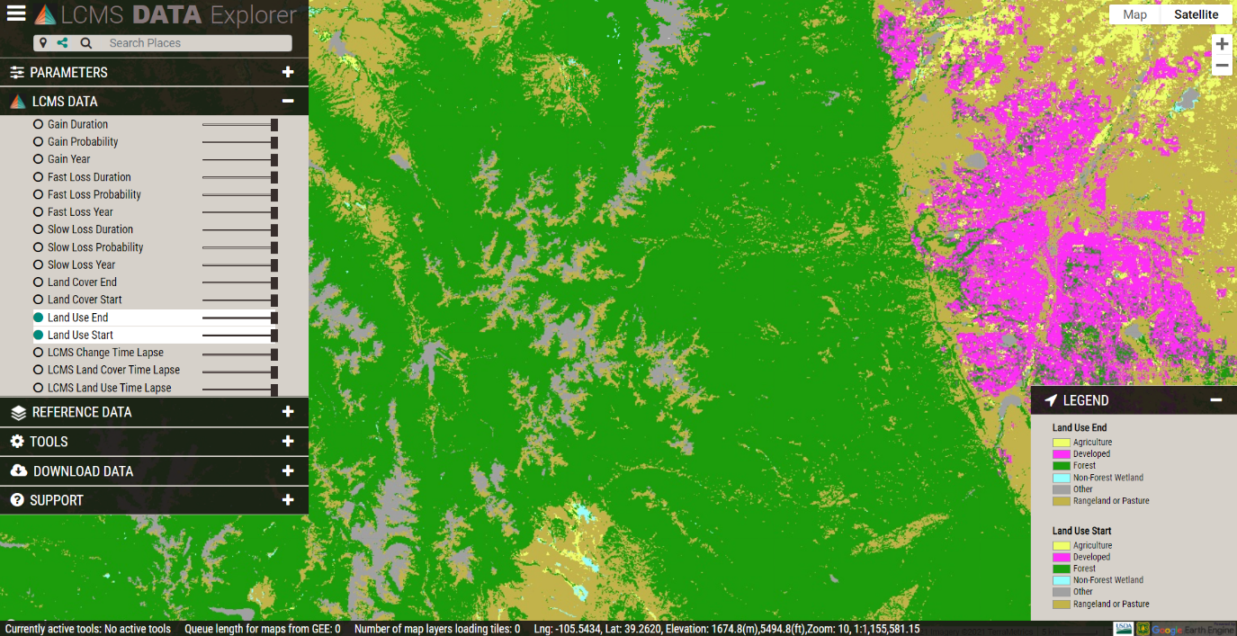Land cover and land use change can be visualized either by using the time lapses or by toggling between the “start” and “end” land cover and land use layers that are created in advanced mode. Click on the land cover and land use start and end year layers to view land cover or land use at the start and end of the analysis year range.
    2. Click on the time lapse layers. When a time lapse layer is activated, all other layers are turned off. They will take a bit to load, so be patient and do not pan around while the maps are loading.
       1. 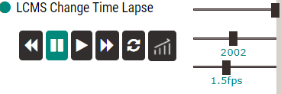Click the  button to playback time lapse annual layers.
       2. Click the button to pause the time lapse playback.
       3. Manually flip through years with the  and  buttons or drag the year slider (middle slider).
       4. Adjust the playback speed (1.5fps) with the lower slider.
       5. If tiles fail to load (holes appear in maps) click the  button
       6. If you would like to view all layers prior to a given year along with that year, click on the  button to toggle cumulative mode.

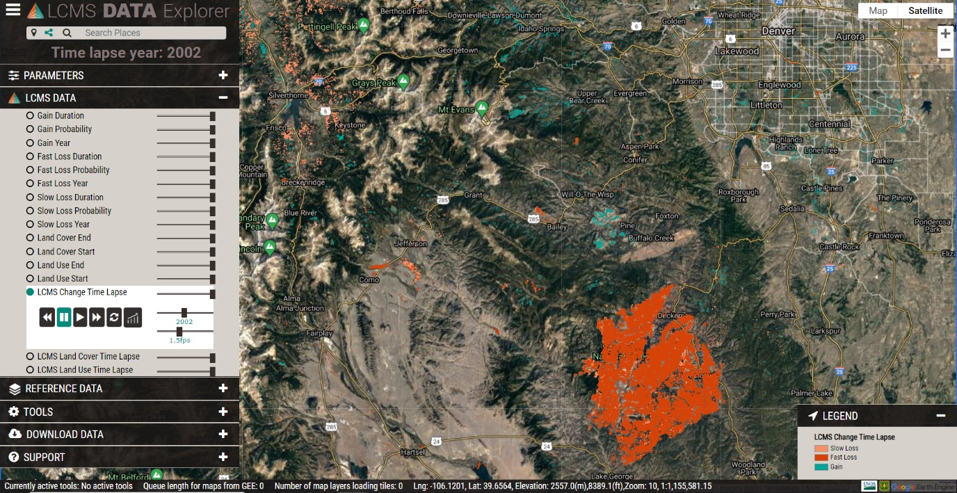Example: Hayman Fire in Colorado – the large area of contiguous fast loss displayed as orange.

* 1. Explore the Reference Data tab
     1. Next, click the **Reference Data** tab. These reference data sets provide additional geospatial information that may be useful for exploring the LCMS data.

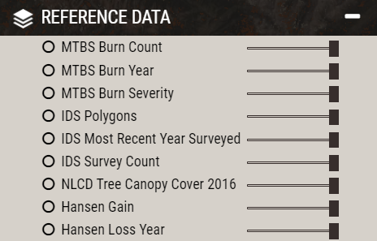

* + 1. This set of reference data allows users to display information directly from the web map without downloading data.
    2. Use the sliders to change the transparency of layers on the display window
  1. 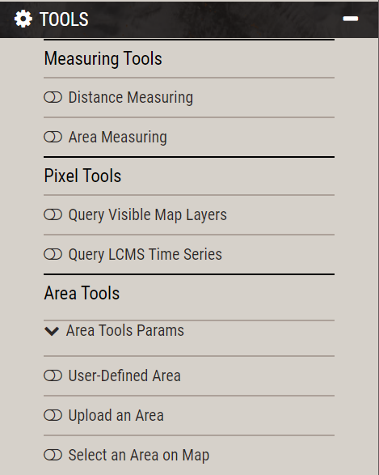Explore the Tools tab
     1. Click on the **Tools** tab
     2. There are three main tools: Measuring, Pixel, and Area. Each tool can be turned on by clicking the slider button located to the left of each tool



* + 1. **Measuring Tools:**
       1. Distance Measuring**:** Click anywhere to begin a linear measurement. The option buttons allow the user to undo, delete, and change the color of the measurement line. The user can also choose Imperial or Metric measuring units.

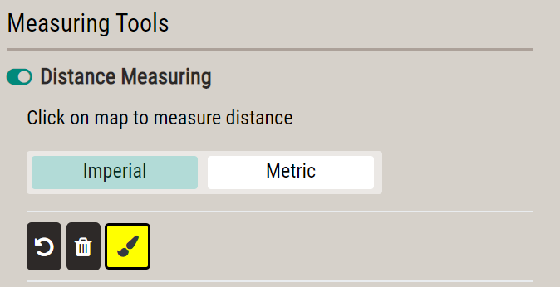

* + - 1. Area Measuring: Click anywhere to begin delineating an area on the map, **single click** to create a vertex, and **double click** to complete a polygon area. The option buttons allow the user to undo, delete, and change the color of the area boundary line. The user can also choose Imperial or Metric measuring units.

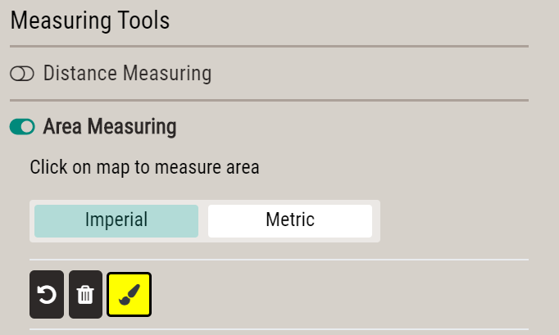

* + 1. **Pixel Tools:** 
       1. Query Visible Map Layers:
          1. Double-click a point of interest in the project boundary. A table will automatically pop up displaying the pixel values for visible LCMS or Reference data layers.
       2. Query LMCS Time Series layers:

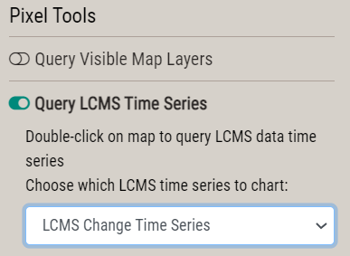

* + - * 1. Choose the LCMS time series to chart by expanding the drop-down menu. Available options are:

LCMS Change Time Series

LCMS Land Cover Time Series

LCMS Land Use Time Series

* + - * 1. Double-click a point of interest in the viewer. A chart will automatically pop up displaying LCMS product information for that point.
        2. Turn layers on and off by clicking their legend entries below the chart.
        3. Note the **Download** button at the bottom right of the chart. Time series charts can be downloaded as a CSV, PNG, or geoJSON.

Select the **Chart Type** button at the bottom right of the chart to view the time series as either a graph or a table of values.

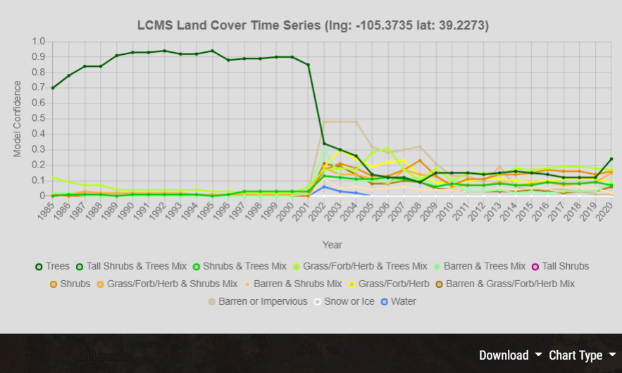

* + 1. **Area Tools:** Summarize LCMS products by area
       1. **User-Defined Area:** Allows the user to draw a polygon and obtain LCMS summaries for the area.
          1. Toggle on the User-Defined Area tool and type a name into the **Name your charting area** box, if desired.
          2. If desired, choose a color for the charting area by clicking the **paintbrush tool.** 
          3. 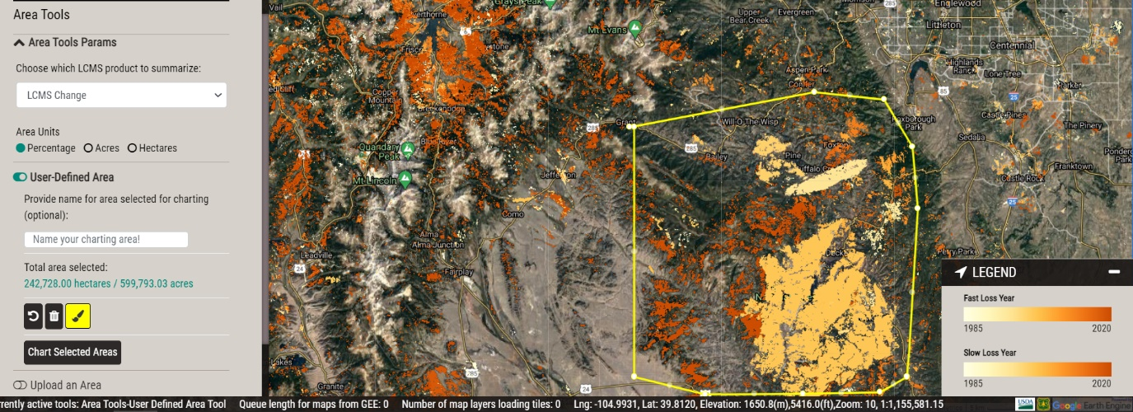 **Outline** the area of interest by clicking to create vertices for a polygon. **Double-Click** to finish drawing the boundary. If another polygon is wanted, repeat this process. Then click **Chart Selected Areas**.

* + - * 1. A chart will populate in the viewer displaying a Loss & Gain time series

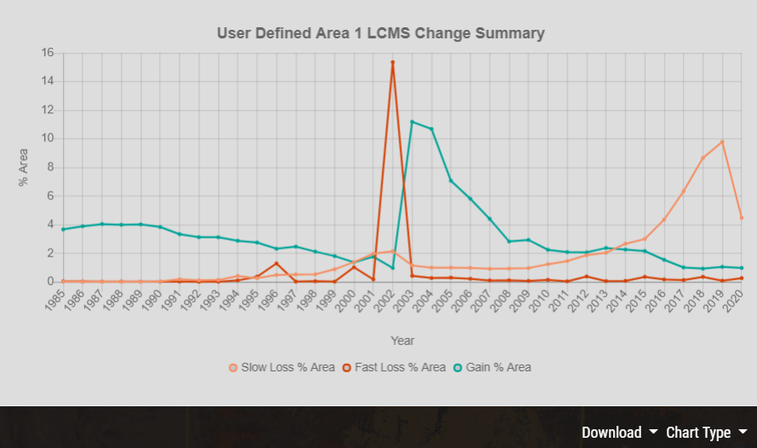

* + - * 1. Note the **Download** button at the bottom right of the chart. Time series charts can be downloaded as a CSV, PNG, or geoJSON.
        2. Select the **Chart Type** button at the bottom right of the chart to view the time series as either a graph or a table of values.
        3. To delete a user defined area of interest and draw a new one, click the **trash can icon**.



* + - 1. **Upload an Area:** The user can input a zipped shapefile (with all the necessary files) or geoJSON file to summarize across. Large shapefiles (vectors > ~5000 vertices or file size > ~50 mb) are not supported and will likely fail. Please contact us if you would like to summarize across a large vector.

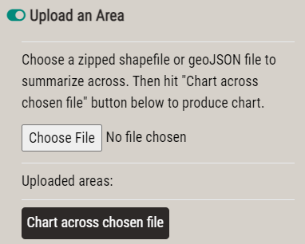

* + - * 1. Click **Choose File** to insert a user shapefile (zipped in a .zip file) or geoJSON.
      1. **Select an Area:** The user can select from a list of pre-defined areas to generate the same summaries outlined above.
         1. 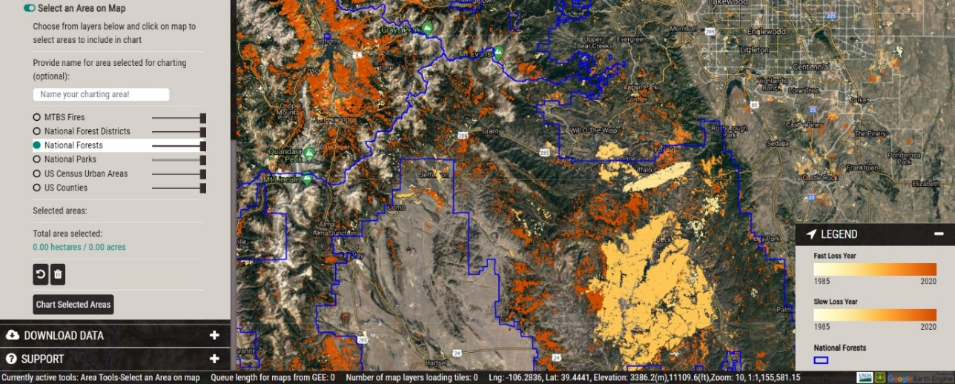Use the radio buttons next to the list of layers to turn on a layer with pre-determined boundaries, and click the polygons to include in the time series chart. Click **Chart Selected Areas** to chart.

1. 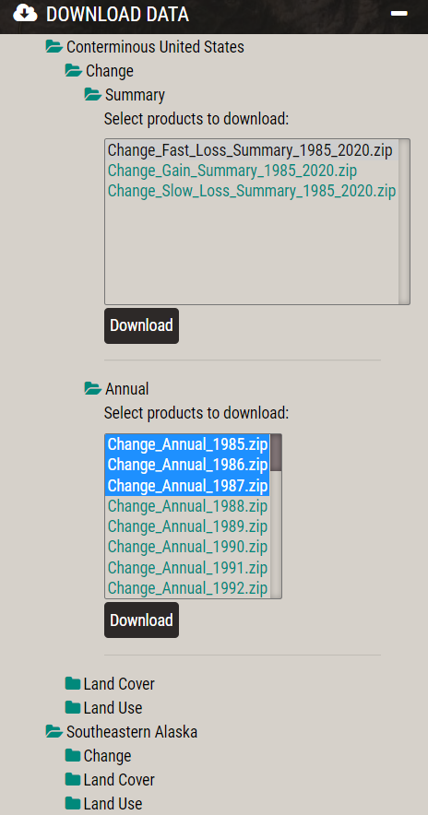Download Data & Support Tabs
   1. Download Data tab
      1. Click on the **Download Data** tab.
      2. LCMS products can be downloaded for the conterminous United States and Southeastern Alaska. **WARNING!! – Downloads for the Conterminous United States are about 1GB per zip file.**
      3. Select/highlight the products to download by dragging your cursor, holding down ctrl or shift, then click on download.
      4. Disable the internet browser pop-up blocker before downloading products.
      5. All downloaded LCMS products include the geospatial data in a geoTiff format (.tif), pyramid file (.tif.ovr), class names (.tif.aux.xml), html metadata (.tif.html), ESRI metadata (.tif.xml).
   2. 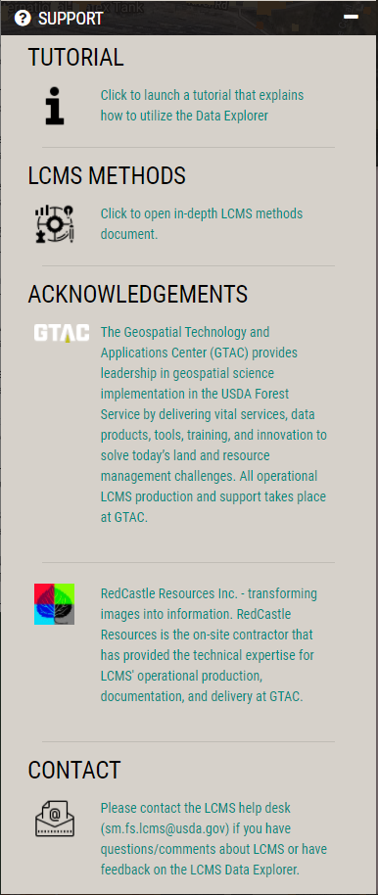Support tab
      1. The tutorial, acknowledgements, and information for contacting the LCMS team is available here.

**Congratulations!** You have successfully completed this exercise. You now know how to navigate the LCMS Data Explorer and download data for use within your own project.